**1. Use administrator account**

**2. The settings are activated immediately**

***3. See if something was blocked automatically***

**4. Use this window for configuration**

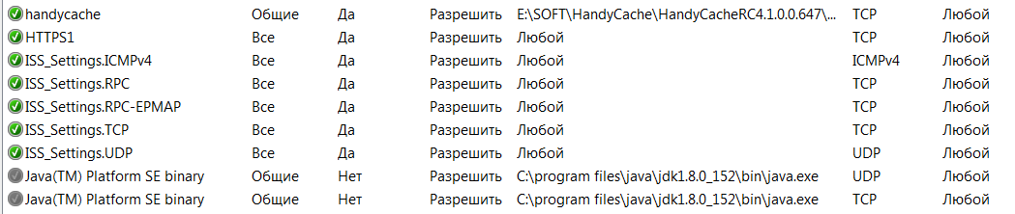

**5. and this for control**

